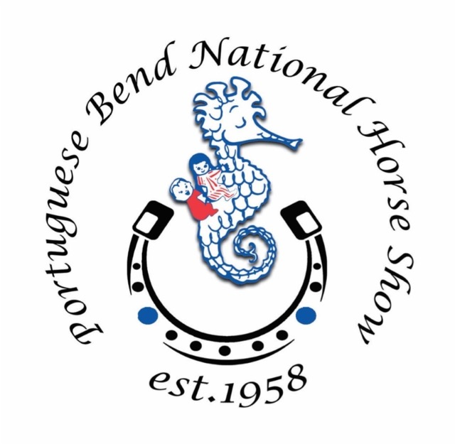
Portuguese Bend National Horse Show

Sponsorship Opportunities

Champion Ribbon Donor
$15,000 Donation of Money, Goods or Services
- Reserved Table for 8 all 3 days of the Horse Show (Value: $500 for 3 days)
- 3 VIP 3-day Parking Passes (Value: $450 each)
- 10 Saturday Night Supper Tickets (Value: $75 each)
- Full Page Color Ad in the Horse Show Program / Signage and Scoreboard recognition at the Show
- Class Sponsor / 50 General Admission Tickets

Reserve Champion Ribbon Donor
$10,000 Donation of Money, Goods or Services
- Reserved Table for 8 all 3 days of the Horse Show (Value: $500 for 3 days)
- 2 VIP 3-day Parking Passes (Value: $450 each)
- 4 Saturday Night Supper Tickets (Value: $75 each)
- Full Page Color Ad in the Horse Show Program / Signage and Scoreboard recognition at the Show
- Class Sponsor / 50 General Admission Tickets

Blue Ribbon Donor
$5,000 Donation of Money, Goods or Services
- Reserved Table for 8 for 2 days (Fri/Sat) of the Horse Show (Value: $450 for 2 days)
- 1 VIP 3-day Parking Pass (Value $450)
- 2 Saturday Night Supper Tickets (Value: $75 each)
- Full Page Color Ad in the Horse Show Program / Signage and Scoreboard recognition at the Show
- Class Sponsor / 25 General Admission Tickets

Red Ribbon Donor
$2,500 Donation of Money, Goods or Services
- Full Page Color Ad in the Horse Show Program
- 15 General Admission Tickets
- Signage and Scoreboard recognition at the Show

Yellow Ribbon Donor
$1,000 Donation of Money, Goods or Services
- Full Page Color Ad in the Horse Show Program
- Signage and Scoreboard recognition at the Show

For more information contact Shari Moore at shariwmoore@gmail.com

Tax Exempt Under IRS Section 501 (c) (3)-Federal Tax ID # 23-7091175
L.A. Police Commission permit on file. Visit www.pcch.net

